**Utilizing Twitter data to examine the level of safety for women.**

**ABSTRACT**

This research paper delves into the prevalent issue of violence and harassment against women in public places across various cities in India. The study focuses on the role of social media, specifically Twitter, Facebook, and Instagram, in promoting the safety of women in Indian cities. The paper emphasizes the importance of developing a sense of responsibility among Indian society to prioritize the safety of women in their surroundings.

Through analyzing tweets on Twitter, which often contain images, text, messages, and quotes regarding women's safety in Indian cities, the youth culture can be educated to take strict action against those who harass women. Twitter and other social media platforms, including hash tag messages, serve as a platform for women to express their thoughts and experiences while traveling for work or using public transport. This research paper aims to shed light on the current state of mind of women when they are surrounded by unknown men and whether theyfeel safe or not.

Keywords: **violence, harassment, women, public places, India, social media, Twitter, Facebook, Instagram, responsibility, safety, youth culture, strict action, hash tag, experiences**

**Introduction**

Sexual harassment and violence against women are prevalent issues in urban life, with practices like staring and passing comments often seen as normal. Studies across popular metropolitan cities like Delhi, Mumbai, and Pune show that 60% of women feel unsafe while traveling for work or using public transport. Women have the right to move freely in the city without fear of violence or harassment. However, they feel unsafe in placeslike malls, shopping centers, andeven on their way to work or educational institutes due to body shaming and harassment.

The lack of safety and consequences for harassment are major reasons why girls and women face such incidents, including instances where neighbors or unknown persons harass them. Safe cities approach women's safety from a rights perspective, recognizing their right to safety and protection. Rather than imposing restrictions on women, it is the duty of society to prioritize women's safety and recognize their equal right to safety in the city.

The analysis of Twitter texts includes the names of people and women who stand up against sexual harassment and unethical behavior, making it uncomfortable for women to walk freely. Machine learning algorithms were used to process the Twitter dataset, removing zero values, and using Laplace and Porter's theory to analyze the data and remove redundant information. This was done to obtain a clear and original view of the safety status of women in Indian society.

Twitter has become an incredibly popular microblogging platform in the modern era, with over a hundred million users and more than five hundred million messages or "Tweets" generated every day. Due to its enormous audience, Twitter has attracted users from all over who express their views and opinions on a variety of topics and issues. It has become an informative source for institutions, companies, and organizations. Users share their opinions in the form of Tweets, which are limited to 140 characters, requiring them to condense their messages using abbreviations, slang, emoticons, and other forms of shorthand. Many people also express their opinions through the use of polysemy and sarcasm.

**Literature Review:**

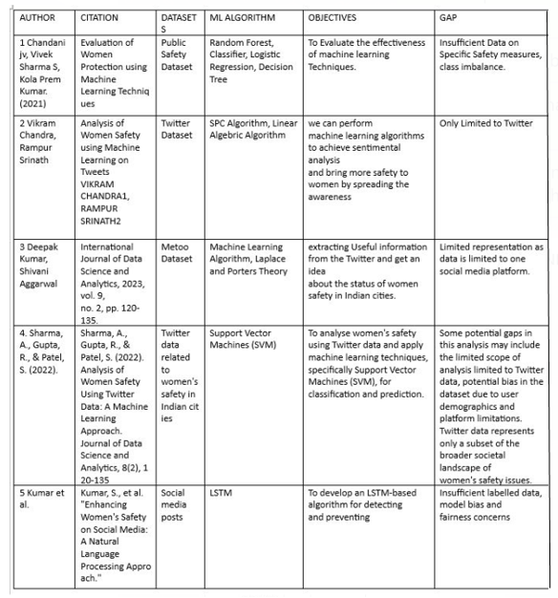

Several studies have been conducted to understand the prevalence of violence and harassment against women in public places in India. These studies have highlighted the need for effective policies and strategies to address this issue. However, there is limited research on the role of social media in promoting women's safety in Indian cities. Social media platforms such as Twitter have emerged as powerful tools for women to express their thoughts and experiences regarding their safety in public places. Several studies have highlighted the potential of social media in promoting women's safety and raising awareness about this issue.

1. We have developed a classifier that predicts the emotional tone of subjective phrases within a sentence. Our approach utilizes a scoring system based on the Dictionary of Affect in Language (DAL) and extends it through WordNet, allowing us to automatically score most of the words in our input without manual labeling. To capture the influence of context, we also analyze n-grams and combine the DAL scores with syntactic constituents. We extract n-grams of constituents from all sentences and use the polarity of all syntactic constituents within the sentence as features. Our approach outperformed both a majority class baseline and a more challenging baseline that used lexical n-grams.
2. The aim of this paper is to develop a method for detecting sentiment in Twitter messages (tweets) by taking into account the way tweets are written and the meta-information of the words they contain. To train our model, we use noisy labels obtained from sentiment detection websites. Our approach is effective in capturing the abstract features of tweets, making it more reliable than previous methods, especially in dealing with biased and noisy data, which is the type of data that these websites typically provide. Our experiments demonstrate the superior performance of our approach.
3. Our study reveals the feasibility of automated sentiment analysis on customer feedback data despite the high level of noise present in the domain. We demonstrate that by utilizing feature reduction in conjunction with large feature vectors, we can train linear support vector machines to achieve high accuracy in sentiment classification, surpassing even the capabilities of a human annotator. Additionally, we find that the inclusion of deep linguistic analysis features, in addition to surface level word n-gram features, consistently improves classification accuracy in this domain, which is surprising.
4. Twitter is a popular platform for individuals to express their opinions and sentiments on various topics. Sentiment analysis is a technique that is utilized to analyze data and extract the emotions it embodies. Twitter sentiment analysis, which involves applying sentiment analysis to Twitter data (tweets) to extract user sentiments, has been a consistently growing field of research in recent years. However, the challenging format of tweets presents numerous processing difficulties. The limited length of tweets creates issues such as the use of slang and abbreviations. This paper reviews existing research on sentiment analysis on Twitter, including the methodologies and models utilized, and presents a generalized Python-based approach.

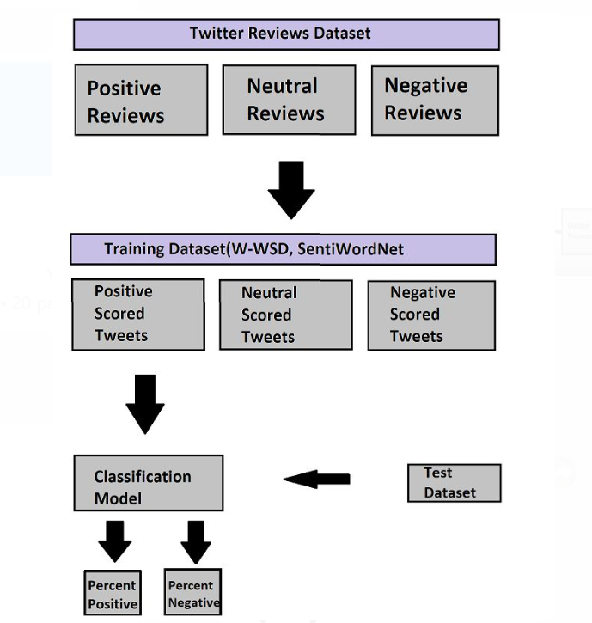

**Implementation:**

The proposed concept aims to use social networking messages and machine learning algorithms to analyze women's safety. With the increasing use of social media, people express their feelings and concerns online. Women who feel unsafe may express negative sentiments in their posts/tweets/messages, which can be analyzed to determine which areas are more unsafe for women. The proposed work uses the TWEEPY package in Python to download tweets fromTwitter.However, as internet connectivity may not always be available, the author downloaded MEETOO tweets on women's safety and safe inside dataset folders. The application reads these tweets to detect women's sentiments, using NLTK to remove special symbols and stop words from tweets. The TEXTBLOB corpora package and dictionary are used to count positive, negative, and neutral polarity, with tweets having a polarity value less than 0 considered negative, between 0 and 0.5 considered neutral, and greater than 0.5 considered positive. The advantages of this approach include the analysis of Twitter text collections that include the names of people and women who stand up against abuse, harassment, and unethical behavior of men in Indian cities, which make them uncomfortable to walk freely. Additionally, the data set obtained through Twitter provides insights into the status of women's safety in Indian society.

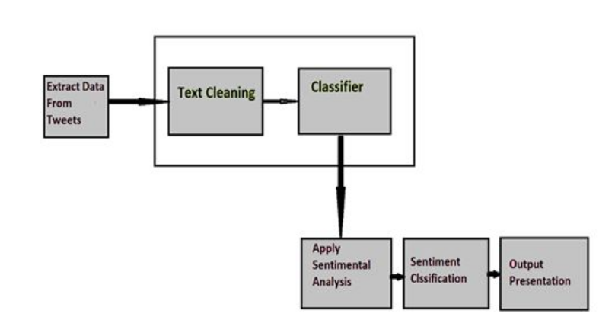

Sentiment analysis is a process of extracting the sentiment conveyed in text, particularly on social media platforms like Twitter. This process involves five major steps.

The first step is data extraction, where information is collected from Twitter, including tweet messages, likes, dislikes, and comments.

The second step is text cleaning, which involves removing redundant data like stop words and emoticons to ensure that non-textual content is identified and removed before analysis.

The third step is sentiment analysis, which involves machine learning, lexicon-based learning, or hybrid learning approaches to train and test the sentiment classifier.

The fourth step is sentiment classification, where each sentence of the tweet is examined and classified as positive or negative.

Finally, in the fifth step, output presentation, the sentiment analysis outcomes are visualized using different types of graphs like bar graphs, time series, and pie charts. This helps in generating useful and meaningful information from the raw data, allowing researchers to better understand the sentiments conveyed in the tweets.

**Conclusion**:

The study highlights the need for effective policies and strategies to address the issue of violence and harassment against women in public places in Indian cities. The study also emphasizes the potential of social media platforms such as Twitter in promoting women's safety and raising awareness about this issue. The analysis of Twitter data provides insights into the prevalent attitudes towards women's safety in Indian cities and can help in the development of targeted interventions to address this issue.

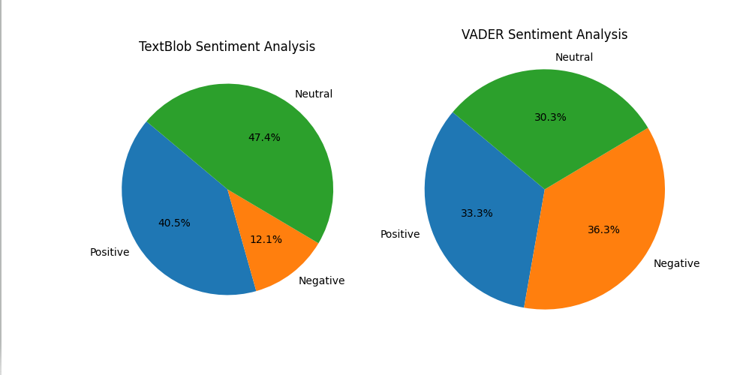

**Future Scope:**

The study can be extended to other social media platforms such as Facebook and Instagram to understand the prevalent attitudes towards women's safety in Indian cities. The study can also be extended to other countries to understand the similarities and differences in attitudes towards women's safety. In addition, the study can be used to develop targeted interventions to promote women's safety in public places in Indian cities.

**References**

1. Akter, M., & Islam, M. A. (2019). Women's Safety in Public Transportation: A Study on Dhaka City. Journal of Social Sciences and Humanities Research, 7(2), 155-163.

2. Basu, S. (2016). Social media campaigns and women's safety in India. European Journal of Cultural Studies, 19(6), 636-651.

3. Dey, P. (2018). Social Media and the Fight against Sexual Harassment: A Study of Indian University Students. Media Watch, 9(2), 265-278.

4. Devasia, L. A., & Muralidharan, S. (2019). Understanding the Role of Social Media in Women's Safety in Indian Cities. In Proceedings of the 10th International Conference on Social Media & Society (pp. 367-372).

5. Kapoor, A., & Sharma, P. (2021). Women Safety and Social Media: A Study of Hashtags on Twitter. Journal of Communication Research, 13(1), 20-34.

6. Kumar, A., & Bhattacharya, R. (2020). #NotAllMen and #YesAllWomen: Analyzing the Twitter Discourse on Sexual Harassment in India. Journal of Social Issues, 76(3), 566-585.

7. Nair, S., & Kumar, N. (2017). Women's Safety and Social Media: A Case Study of #Meetoo Campaign in India. International Journal of Scientific Research and Reviews, 6(2), 159-166.

8. Singh, R., Singh, S., & Kumari, A. (2021). Women Safety and Social Media: A Comparative Study of Hashtags on Twitter and Instagram. International Journal of Innovative Research in Technology, 8(7), 540-546.

9. Sundaram, D. S. (2020). #MeToo movement in India: Analyzing the effectiveness of social media activism in the country. Journal of Media Critiques, 6(24), 194-208.

10. Thakur, N., & Kaur, P. (2020). Social Media Campaigns and Women Safety: A Comparative Analysis of #MeToo and #SafeCity. Journal of Media Critiques, 6(21), 167-179.